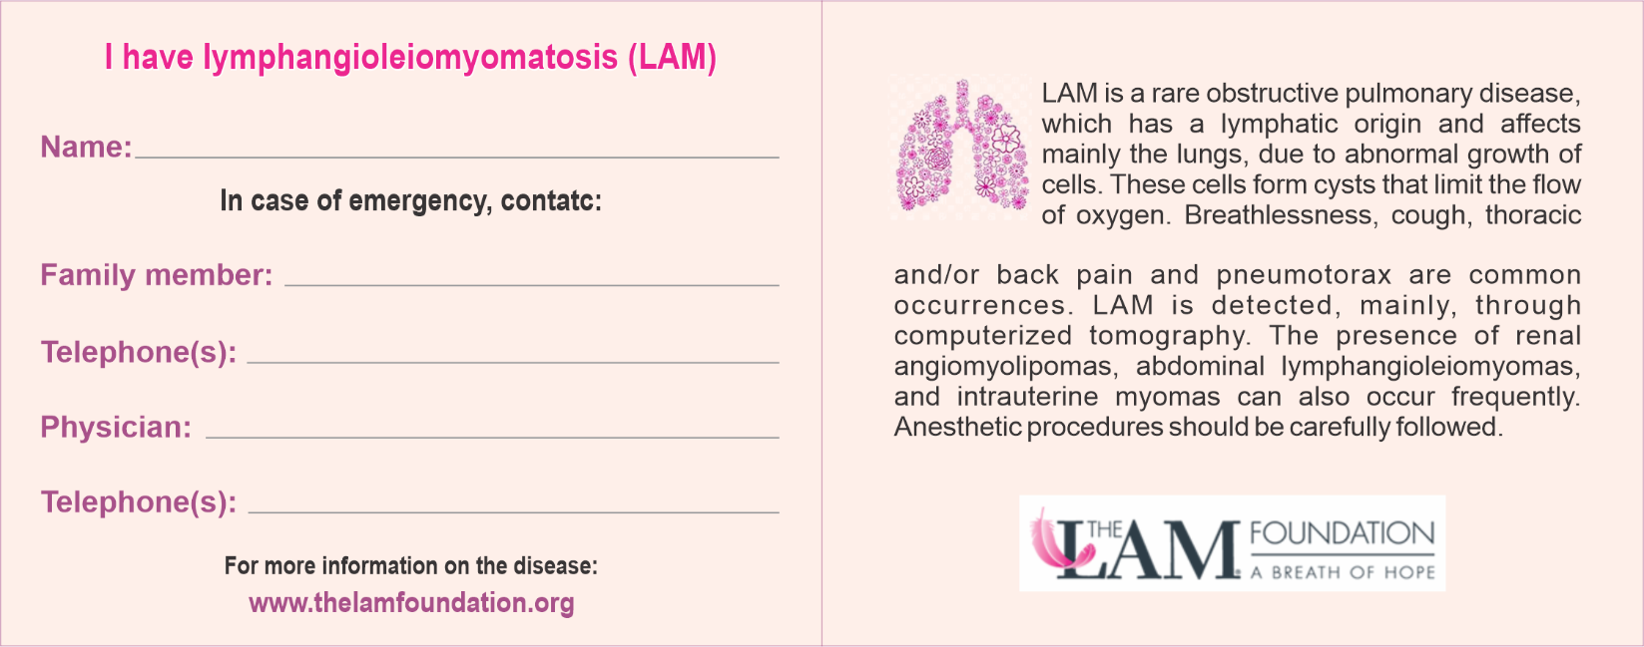
Telephone
Physician
Family member
Telephone
Name

